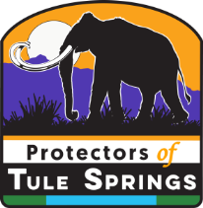
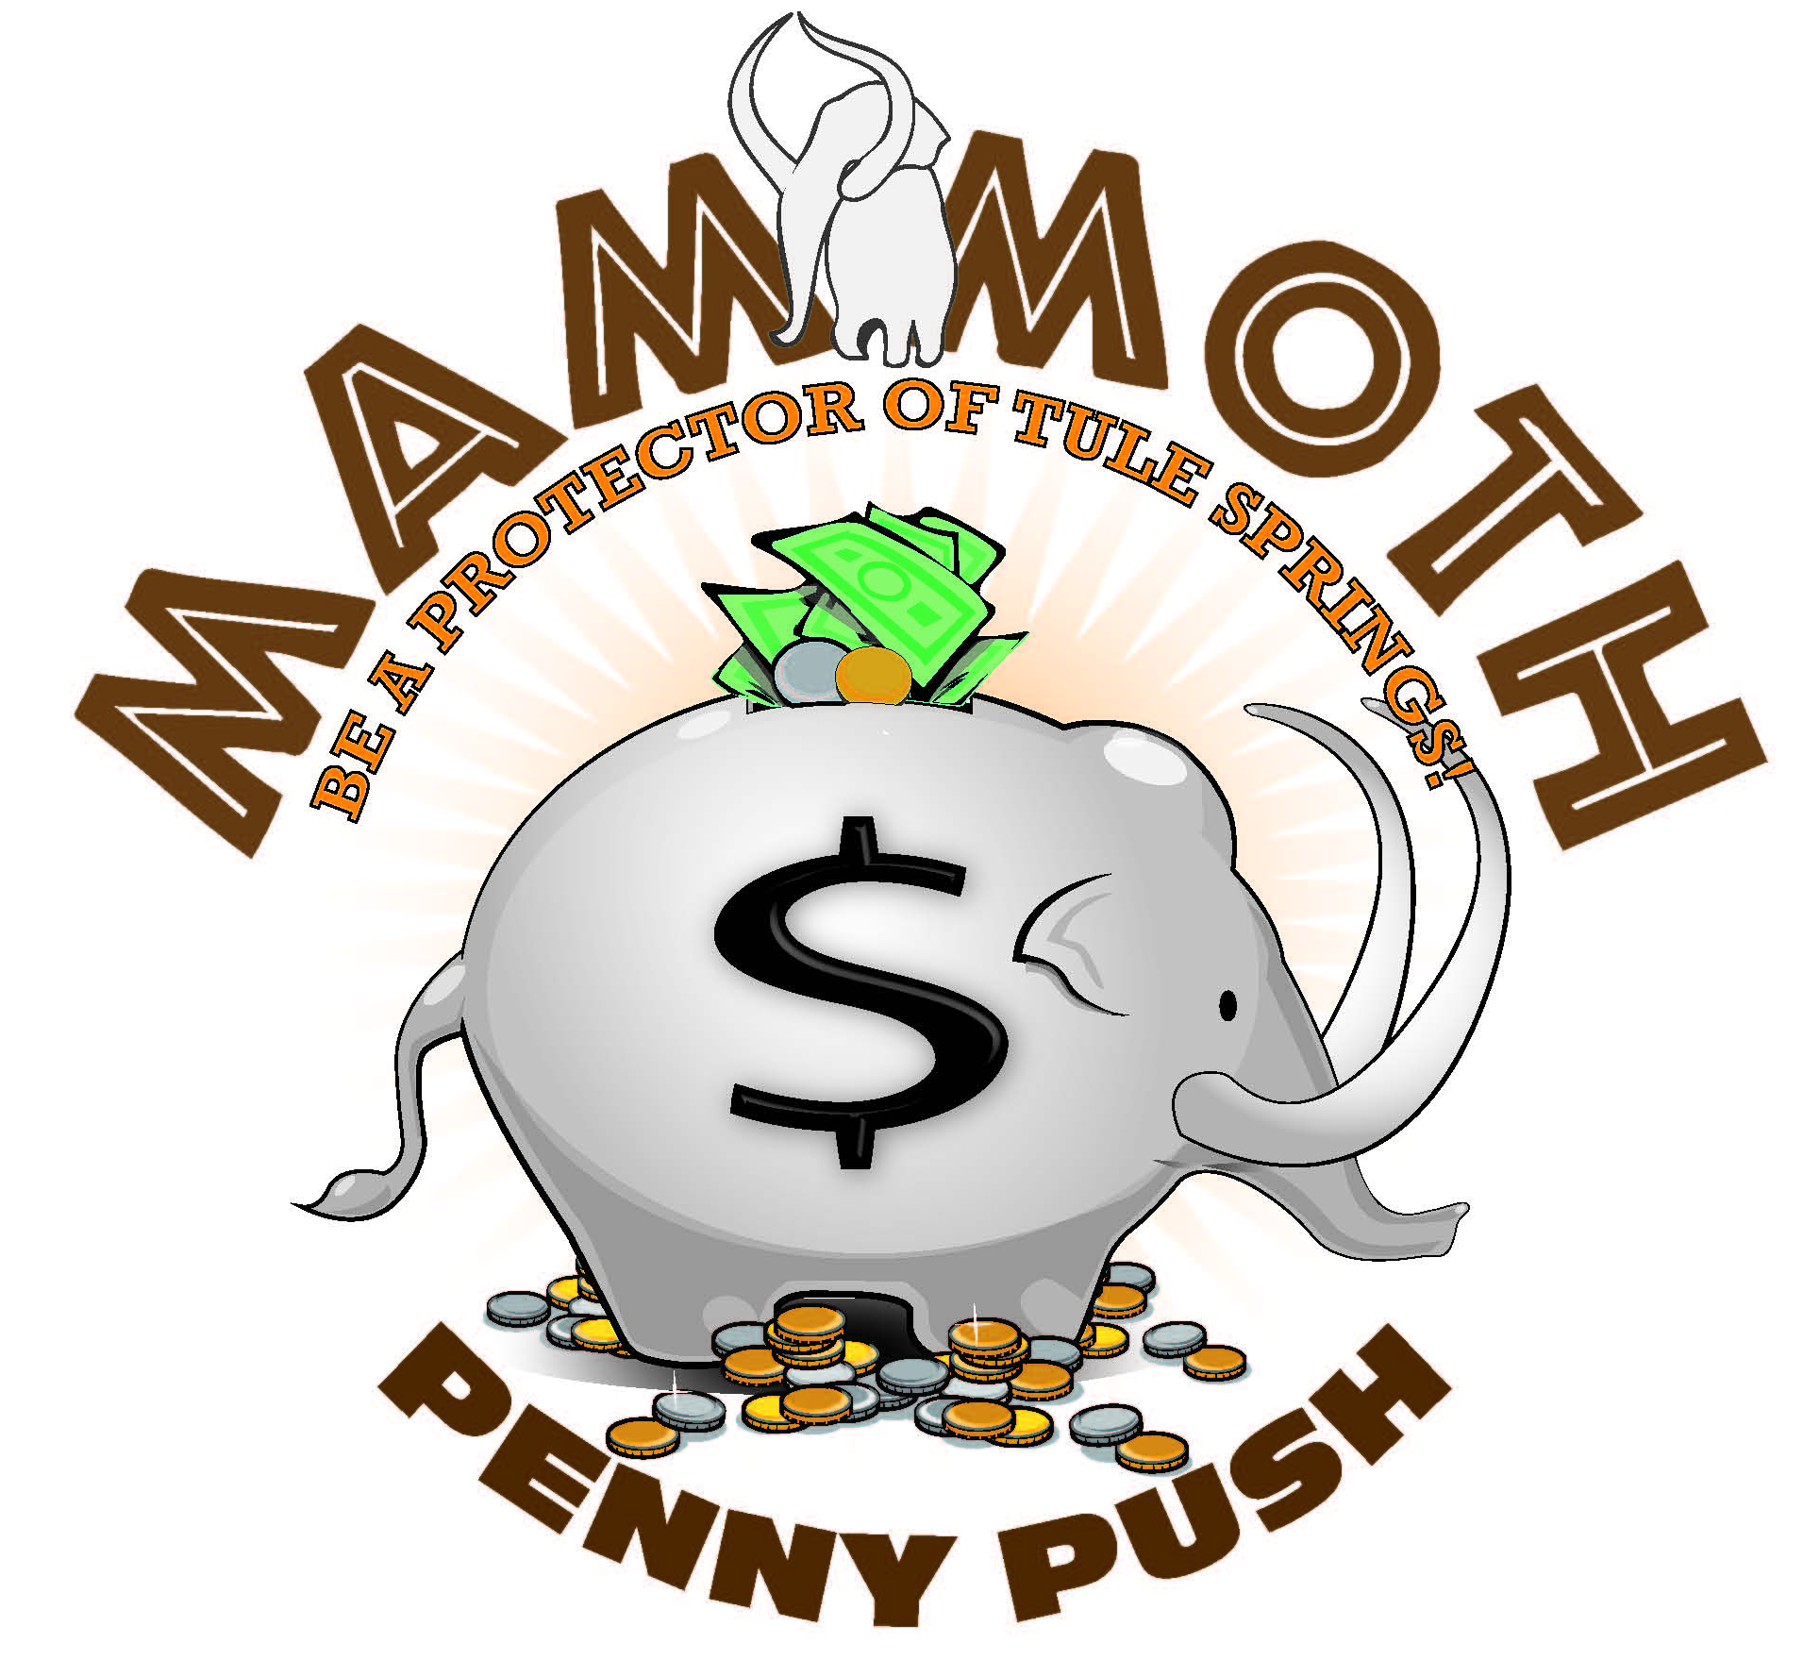

[DATE, 2017]

Dear CCSD Parent/Guardian:
In March, [school name] students will be participating in the “Mammoth Penny Push,” a program to raise awareness of and funds for the development of the Tule Springs Fossil Beds National Monument. By participating in this program, your student will be part of a historic project – building a new National Park Unit that will benefit students for generations to come.

The nearly 23,000 acres of the national monument contain the fossils of animals that walked the Las Vegas Valley until the end of the last ice age. Ancient Columbian mammoths, camels, bison, sloths, and saber-toothed cats are all buried in the dry spring mounds of the Upper Las Vegas Wash. The Tule Springs Fossil Beds have been described as one of the most significant ice age fossil sites in North America and possibly the world. The preservation of these lands by the National Park Service will pave the way for the study of the fossils of these creatures – not only by scientists – but by students, teachers, and parents, who will one day be able to tour the national monument and learn about our community’s past.

The nonprofit organization, Protectors of Tule Springs (POTS), has worked for years to protect these lands from development and to create the Tule Springs Fossil Beds National Monument. POTS is now assisting the National Park Service with educational outreach and fundraising to clean up and restore the public’s land, and ready it for local visitors and tourists. Clark County’s students are being encouraged to help POTS in their efforts.

During March, your student will learn about the monument and its scientific significance. Then, from March 27-31, 2017, students will be encouraged to donate spare change to the “Mammoth Penny Push” at their schools. Funds raised will be used to create educational resources for classrooms and future educational opportunities for Clark County schoolchildren. Prizes will be awarded to schools and classrooms to reward students for their efforts and contributions.

The Tule Springs Fossil Beds National Monument will offer important educational opportunities for your student in the future. The “Mammoth Penny Push” will teach your child valuable lessons about preserving our past, respecting our world, and conserving for our future. Please ask your child about what they’ve learned about Las Vegas’s past and encourage them to help build their park with their spare change.

For more information on the Tule Springs Fossil Beds National Monument or The Protectors of Tule Springs, visit: nps.gov/tusk tulespringslv.com
Or follow us on social media:
facebook.com/groups/protectorsoftulesprings/ facebook.com/TuleSpringsNPS/
twitter.com/tulespringsnps twitter.com/students4tule
instagram.com/students4tulesprings/

We thank you in advance for your support of this important educational outreach and fundraising campaign.

